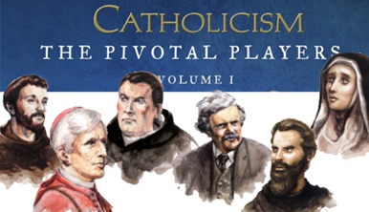

**CATHOLICISM*:*** *The Pivotal Players* showcases a handful of saints, artists, mystics, and scholars who not only shaped the life of the Church but changed the course of western civilization. **Join us this summer on Thursday evenings at 7pm in the Parish Center Library** to view and discuss the lasting influence of these *Pivotal Players.* Please contact, **Sheila Noble at** [**snoble@stfrncis.org**](mailto:snoble@stfrncis.org) **if you have any questions.**

**July 6th—**St. Thomas Aquinas, the Theologian, demonstrated that faith and reason at not at odds, as they come from the same source.

**July 13th—**G.K. Chesterton, the Evangelist, publicly, humbly, and humorously announced the paradoxes and truth of Christianity.

**July 20th—**Michelangelo, the Artist, dramatically demonstrated that beauty and creativity are a primary route of access to God.

**August 3rd—**St. Francis of Assisi, the Reformer, radically and literally lived as Jesus commanded to transform the Church.

**August 10th—**Blessed John Henry Newman, the Convert, left a prestigious career to seek and preach the apostolic faith.